**SYSTEM REQUIREMENT SPECIFICATION**

**FOR**

**CAFÉ MANAGEMENT SYSTEM**

**SUBMITTED BY:**

**Vishwa Chaturvedi**

(Enrollment No.: 201806100110127)

Semester 3-B

**Kruti Devadhara**

(Enrollment No.: 201806100110040)

Semester 3-B

**System Analysis and Design**

**Babu Madhav Institute Of Information Technology**

**Uka Tarsadia University, Bardoli**

|  |  |
| --- | --- |
| **Sr. No.** | **Contents** |
| **1** | Introduction |
| 2 | Problem Definition |
| 3 | Document purpose |
| 4 | Objective |
| 5 | Scope |
| 6 | Functional Requirement |
| 7 | User characteristics |
| 8 | Data Flow Diagram  a. Context Level DFD  b. Zero Level DFD  c. First Level DFD (Any 2 Process) |
| 9 | Event Response Table |
| 10 | Questionnaires  a. Write 20 Questions  b. Follow any structure(Pyramid, Funnel, Diamond) |
| 11 | Process specification format (Any two process) |
| 12 | Data Dictionary |
| 13 | Input form |

**INTRODUCTION**

This document is intended to for different type of readers such as café owner, the system designer, the system developer and the tester. By reading this document a reader can learn about what the project is implemented for and how it will present it’s basic idea. This document has a sequential overview of the whole project so if a reader reads the document from top to bottom, he / she will get a clear idea about the project.

**PROBLEM DEFINITION**

Managing the café and all its orders and payments with special offers and discounts is so unorganized when you tend to do it manually. So basically there is a vast need to organize their paperwork and accounting system. The existing method is highly manual involving a lot of paper work and calculation and this led to inconsistency and inaccuracy in the maintenance of the data .The data which is stored on the paper may be lost, stole or destroyed due to natural calamity.

To make this task easy we propose a “CAFÉ MANAGEMENT SYSTEM”. This will eliminate all the traditional (manual) way of managing a café and provide an ease in managing all the tasks of café to be done satisfyingly.

**DOCUMENT PURPOSE**

This document gives a detailed description of the objectives, features, user-interface and application of the “café management system” in real life. It will also describe about the working of system and under which it must operate. User interface will be shown in this document. Both the user and the developers of the system will be benefited from this document.

**PRODUCT SCOPE**

This system will help to manage and run the café business systematically. In this management system we will provide an app that can be used by the owner and to manage the orders and serve their customer.

Where the employee (waiters) of the café will take order and the order is shown in both owner’s screen and the kitchen where the order is to be made by chef. The customers can also give the feedback through this app so that the owner can evaluate accordingly. The customers can also make payments through debit and credit cards. All the information about the daily expenses and profit will be saved in the system for the owner. Also the required information about the employees will be saved in the system which can be accessed only by the system admin.

The system is useful to: ADMIN, OWNER, WAITERS, CHEFS, CUSTOMERS (JUST FOR FEEDBACK).

**OBJECTIVE**

This café management system helps the café’s manager to manage the café more effectively and efficiently by computerizing the orders, billing and transactions.

This system will also help the manager to make appropriate business decisions for the café as the transactions and other information of staff will be stored in the system. The waiters will not have to approach to the kitchen area again and again for a single order as it is been displayed there in kitchen area’s screen, what is to be made and at the owner to keep the record for the orders of each customer. Moreover, there will be easy calculation of daily expenditure and profit. The whole system is designed for a general computerize digital café. So that any café owner can get it and start automated process of his own café.

**FUNCTIONALITY**

1. Login

2. Registration (getting customers personal details) for each customer6

3. Product categories (menu)

4. Take order

5. Making order

6. Serving order

7. Payment

8. Feedback

**USERS AND THEIR CHARACTERISTICS**

1. **Admin or the ownerb**

* The main person in the cafeteria who is having all the rights to access the system and view all the information whether it is about the customer, the employee, the goods needed, the

goods available and the feedback given by the customers. The one who is responsible for establishing and maintaining daily menus/offers(if any). And the admin also needs to edit the café’s menu periodically.

1. **Cafeteria staff**

* Which includes :

1. the waiters
2. the chefs

* the process will impact café’s 20 employs including both the waiters and the chefs ,
* Waiters:- who will receive / take the order from the customers through the tablets(installed our system) send it to the chefs to indicate the making of order. They will also make sure of order being served by checking the “order served” option. Will make a bill and send a copy of this to the owner’s pc and complete the process.
* Chefs:- who will receive the item name to be made and and will also give the updates to the waiters for order being made and ready for serving.
* MOST OF THE CAFETERIA STAFF WILL HAVE TO BE TRAINED FOR THE USE OF SYSTEM .

1. **CUSTOMER**

* Customer is also the user of this system as they will be using it for the feedback purpose which they will be giving in the tablets itself.

**DATA FLOW DIAGRAMS**

1. Context level DFD

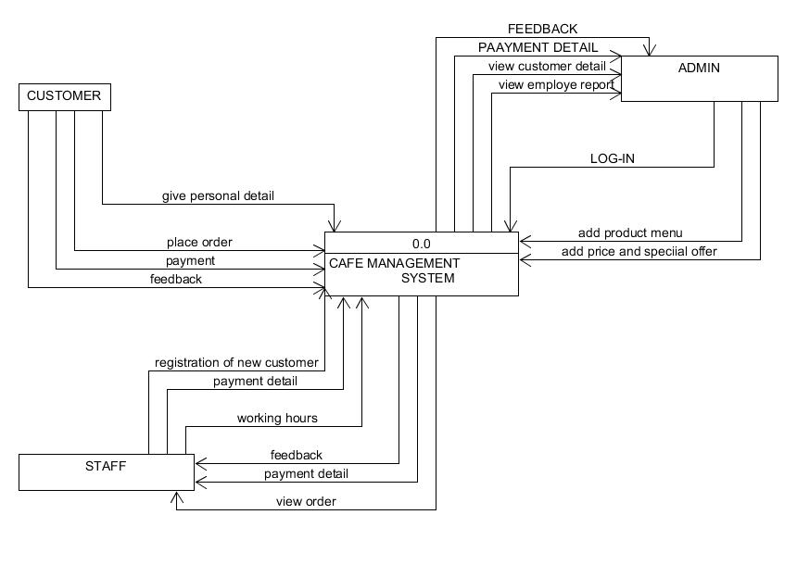

1. **0 level DFD**

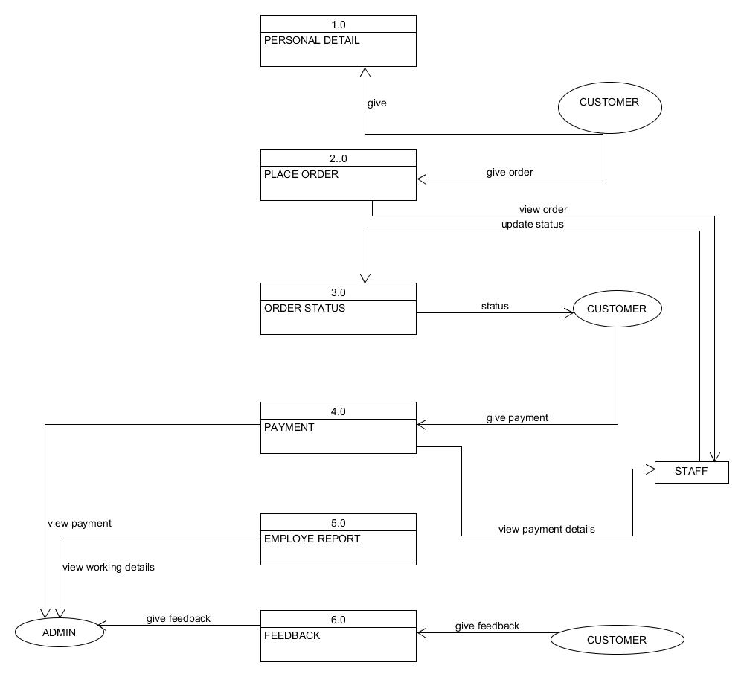

1. **1st level DFD of order process**

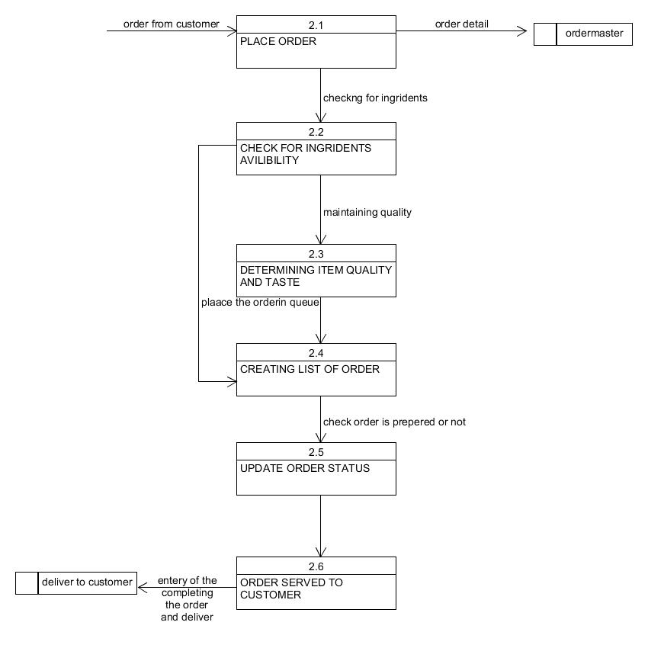

1. **1st level DFD of payment process**

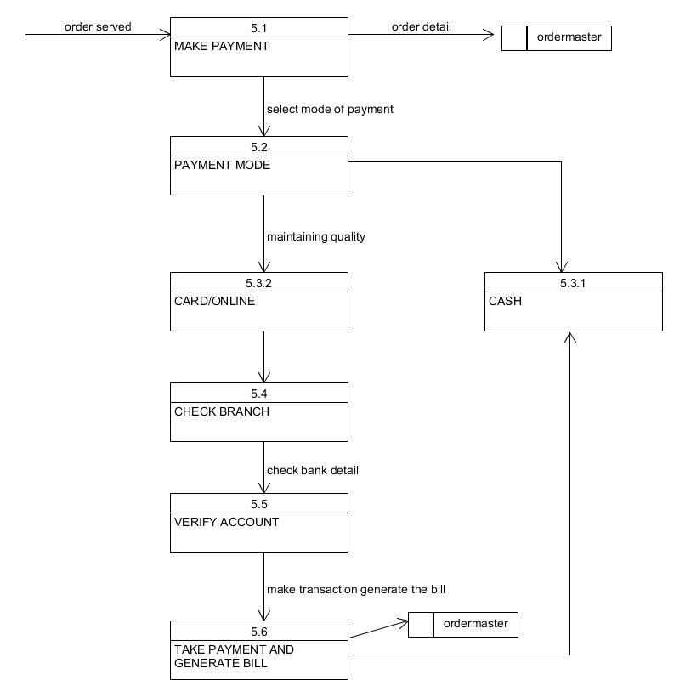

**EVENT RESPONSE TABLE:**

|  |  |  |  |  |  |
| --- | --- | --- | --- | --- | --- |
| **EVENT** | **SOURCE** | **TRIGGER** | **ACTIVITY** | **RESPONSE** | **DESTINATION** |
| admin log in | Admin | Admin user name and password | Verify id and password | Welcome page | System |
| registration of customer | Staff | Customer user name and password | Entry of new customer | New customer added | System |
| Customer give order | customer | Menu and special offer information | Display no. of items ordered | Order placed | Customer |
| Customer served by order made | Staff | Order served | Order being served to customer | Enjoyed the food | Customer |
| Customer makes payment | customer | Credit card information/  net banking | Verification of card’s company | Payment received | Customer/credit card company |
| Customer feedback | customer | Review about the café | Observation regarding service and food of café | Feedback received | System |

**QUESTIONNARIES:-**

1. Is there any problem with your traditional system?
2. What is your objective?
3. What is your budget?
4. Who will be using the system?
5. You want an online system or a desktop system?
6. How many staff members do you have?
7. How many tables do you manage?
8. Do you want the order to be displayed to the chefs in the kitchen?
9. Will you provide some special offers to the customer and your members on festive and other occasion?
10. What will be the duration of membership?
11. Which type of payment method you will prefer?
12. To whom you want the customers and order details should be viewed ?
13. Do you want to get notified by the system when you inventory is about to finish?
14. Do you want the system to generate the employee report with their working hours and standard of working?
15. Will you allow the customers to give feedback and their reviews?
16. What details you want the system to store about the staff, the customers and the inventory of the café?
17. List out the problems that you have with the old system.
18. Why you want to create this café management system?
19. Do you want a cash memo to be generated at the end of transaction and why?
20. What other functional requirements you want to add that you think will improve the system and uniqueness?

**PROCESS SPECIFICATION FORMAT**

**1.**

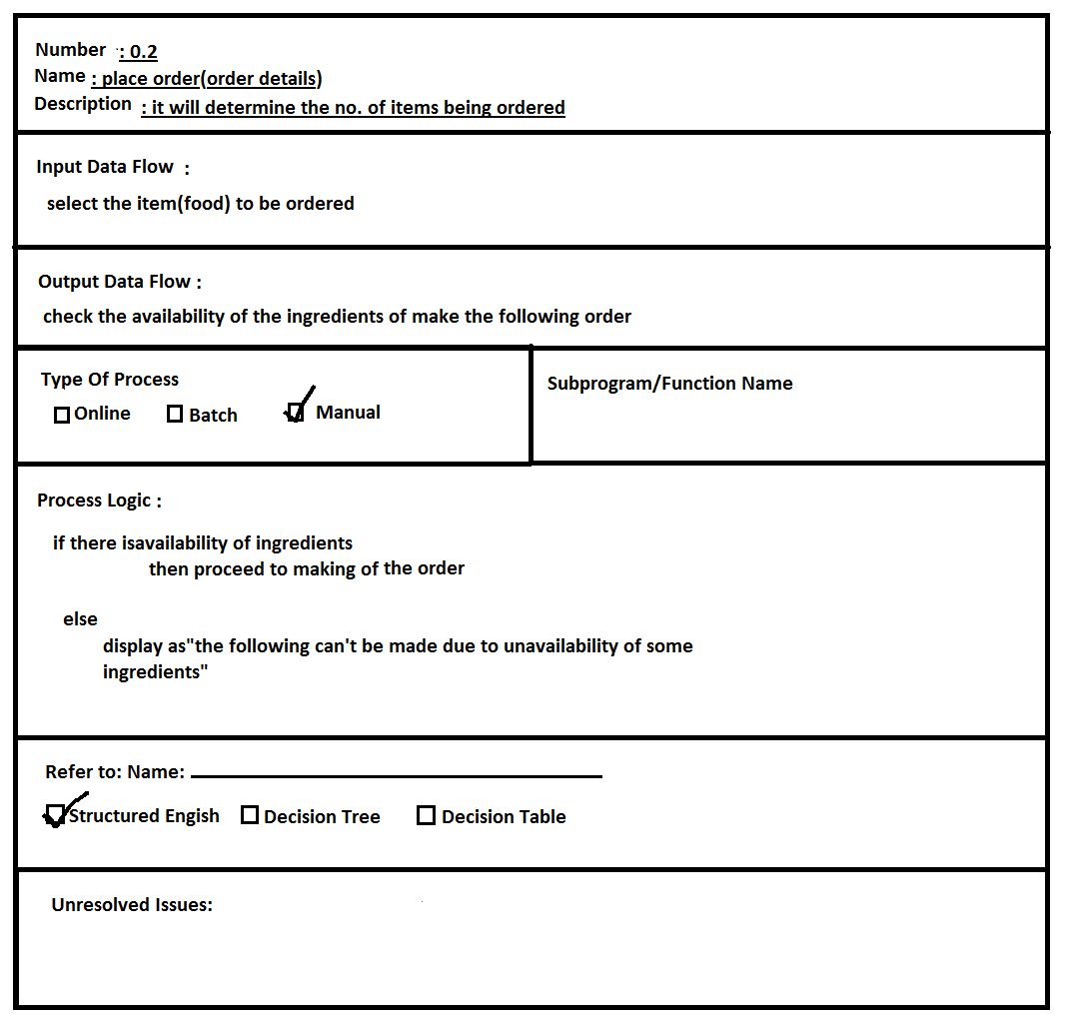

**2.**

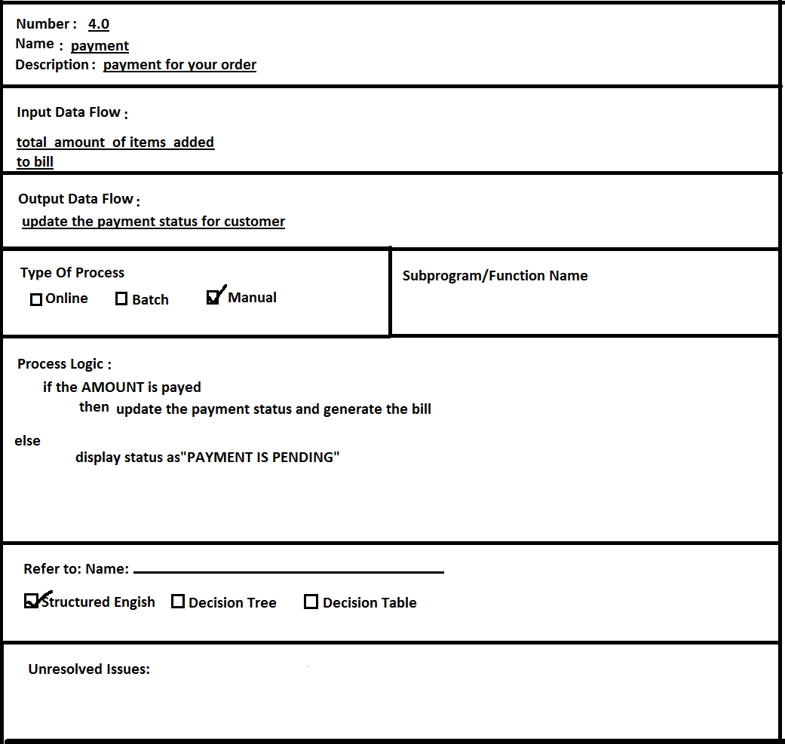

**DATA DICTIONARY**

1. **CUSTOMER MASTER=**

CUSTOMER NAME+

CUSTOMER NUMBER+

CUSTOMER MOBILE_NUMBER+

ADDRESS+

CITY

1. **ORDER MASTER=**

Item name+

Item number+

Price+

Quantity+

Payment

* **Input Forms**

✓ **Login Form**

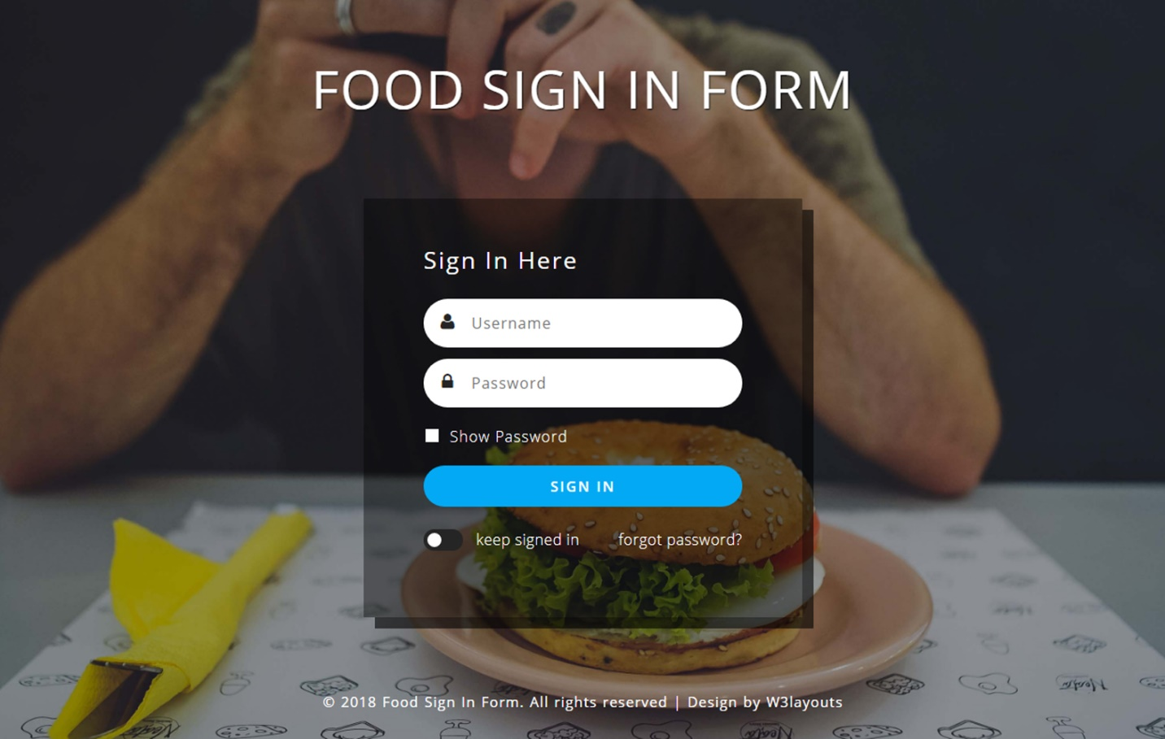

✓ **Menu Form (take order)**

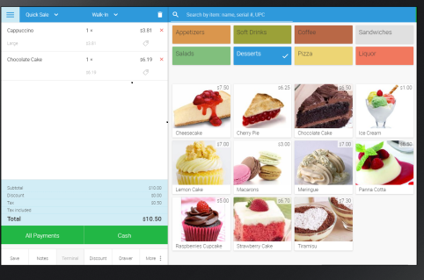

✓ **Feedback Form**

